Faster Hologram Generation and reconstructed image quality enhancement using Distributed Wavefront Recording Planes

Md Sifatul Islam¹, Yang-Ling Piao¹, Md. Shahinur Alam¹, Young-Tae Lim¹, Kwon-Yeon Lee², and Nam Kim^{1,*}
¹School of Information and Commu. Eng., Chungbuk National Univ., Cheongju, Chungbuk 361-763, Korea
²Department of Electronics Engineering, Sunchon National University, Jeonnam 57922, South Korea
* namkim@chungbuk.ac.kr

Abstract― In this paper, a method for enhancement of reconstructed image quality and faster calculation speed using Distributed Multiple WRPs (D-MWRPs) is presented. Depth ranges are created based on the number of object points and WRP is set closest to the depth layer with highest number of object point. Due to creation WRPs closer to the maximum number of object point calculation time for recording light intensity on the WRP is greatly reduced. Moreover higher intensity is recorded which would produce higher quality reconstructed images. Computer simulated results for the proposed method are shown.
I. Introduction
Computer Generated Hologram (CGH) is the method of digitally generating holographic interference patterns. Shimobaba et al. introduced wavefront recording plane (WRP) [1]. In this method, the optical field from the object is calculated on the virtual plane (WRP) first and then propagated to the CGH plane by a Fast Fourier transform (FFT). Recently, Hasegawa et al. presented a method that automatically optimizes the number and arrangement of WRPs to accelerate CGH generation [2]. In this paper, we focus on faster calculation and reconstructed image quality by dynamically creating WRP based on the number of object points on each layer.
II. Result and Discussion
In Conventional Multiple WRPs (M-WRPSs) method object is divided into depth ranges with equal number of depth layers within a depth range. Then WRP is created in the middle of the depth range. However, in this paper D-MWRPs method is proposed where object is divided into depth ranges based on the number of object points in the depth layers and differences between the numbers of object points in neighboring layers. Then WRP is created closest to the depth layer with maximum number of object points within the depth range, as shown in Fig.1.
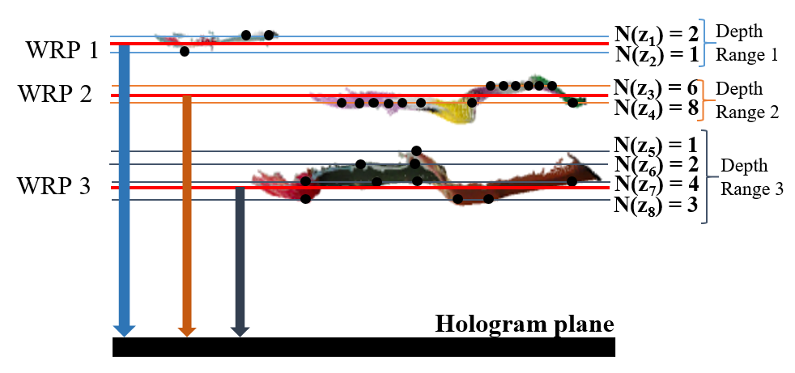
Fig.1 Schematic diagram of D-MWRPs method

D-MWRPs method is compared with conventional M-WRPs method, using point cloud of three objects having 35,263 object points and 1 mm depth. For each method 512 X 512 image was reconstructed at distance of 13cm from the object, and pixel pitch of 7.4µm. For Conventional M-WRPs method minimum calculation time, maximum PSNR are 120.9 sec, 15.24 and for D-MWRPs method are 106.97 sec, 15.69 respectively. The reconstructed image using conventional M-WRPs method and D-MWRPs method, is shown in Fig.2 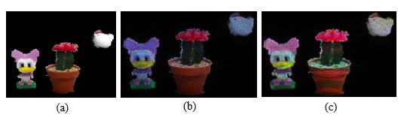
Fig.2 (a) Original image, reconstructed image using (b) conventional M-WRPs method and (c) D-MWRPs method

Creation of WRP closest to the depth layer with maximum number of object point ensures shortest distance between the WRPs and maximum object point of the whole object. Thus calculation time is reduced and higher intensity is recorded.
Acknowledgements
This work was supported by Institute for Information & communications Technology Promotion (IITP) grant funded by the Korea government (No.2017-0-00417, Openholo library technology development for digital holographic contents and simulation), and supported by the National Research Foundation of Korea (NRF) grant funded by the Korea government (No. NRF-2017R1A2B4012096).
References
[1] Tomoyoshi Shimobaba, Nobuyuki Masuda, and Tomoyoshi Ito, "Simple and fast calculation algorithm for computer-generated hologram with wavefront recording plane," Opt. Lett. 34, 3133-3135 (2009)
[2] Naotaka Hasegawa, Tomoyoshi Shimobaba, Takashi Kakue, and Tomoyoshi Ito, "Acceleration of hologram generation by optimizing the arrangement of wavefront recording planes," Appl. Opt.56, A97-A103 (2017)

